Exploratory Data Analysis (EDA) on the Iris Dataset
Week 01 - Task 01 Report

1. Objective
The goal of this task is to perform Exploratory Data Analysis (EDA) on the well-known Iris flower dataset. EDA is a foundational step in any data science project, it helps us understand the structure, quality, and patterns in the data before building any model. This includes checking for missing values, understanding feature distributions, and visualizing relationships between features and the target (species).

2. Dataset Description
The Iris dataset contains 150 samples of iris flowers, evenly split across three species: setosa, versicolor, and virginica (50 samples each). Each sample has four numeric features, all measured in centimeters:
- Sepal Length
- Sepal Width
Petal Length
- Petal Width
The dataset was loaded using scikit-learn's built-in load_iris() function and exported to a local CSV file for use in the notebook.

3. Methodology
The analysis followed these standard EDA steps:
- Loaded the dataset and inspected its shape, data types, and basic structure.
- Checked for missing values and duplicate rows to confirm data quality.
- Generated descriptive statistics (mean, min, max, standard deviation, etc.) for each feature.
- Examined class balance (sample count per species).
- Visualized individual feature distributions using histograms and boxplots.
- Explored relationships between feature pairs using scatter plots, a pairplot, and a correlation heatmap.

4. Data Quality Findings
- Shape: 150 rows × 5 columns (4 features + species label).
- Missing values: none found in any column.
- Duplicate rows: none found.
- Class balance: perfectly balanced, 50 samples per species.
These findings confirm the dataset is clean and ready for visualization and modeling without any additional preprocessing.

5. Visualizations and Insights

5.1 Feature Distributions
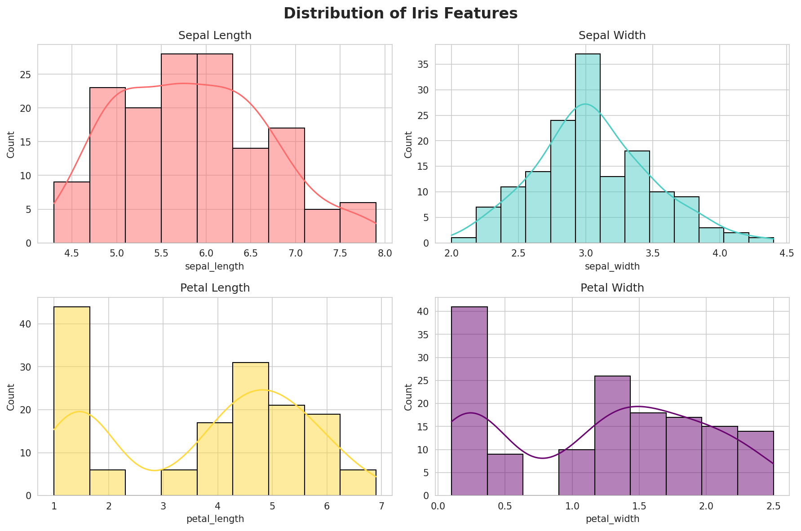
Figure 1: Histograms showing the distribution of each feature.
Petal length and petal width show a clearly bimodal / multi-cluster distribution, hinting at the separation between species, while sepal width is closer to a normal distribution.

5.2 Boxplots by Species
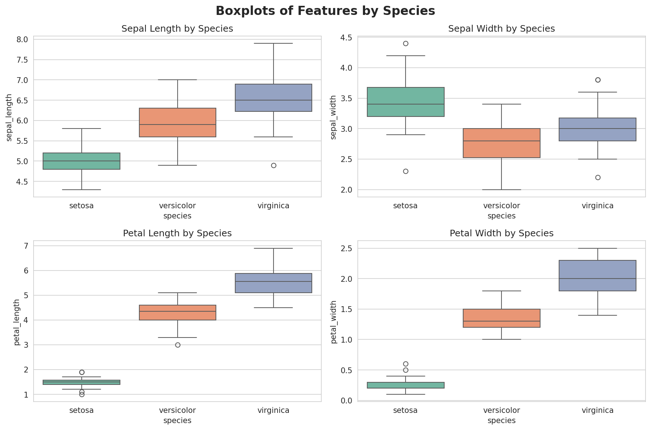
Figure 2: Boxplots of each feature grouped by species.
Petal length and petal width show the clearest separation between species, with setosa having noticeably smaller petal measurements than the other two species.

5.3 Petal Length vs Petal Width
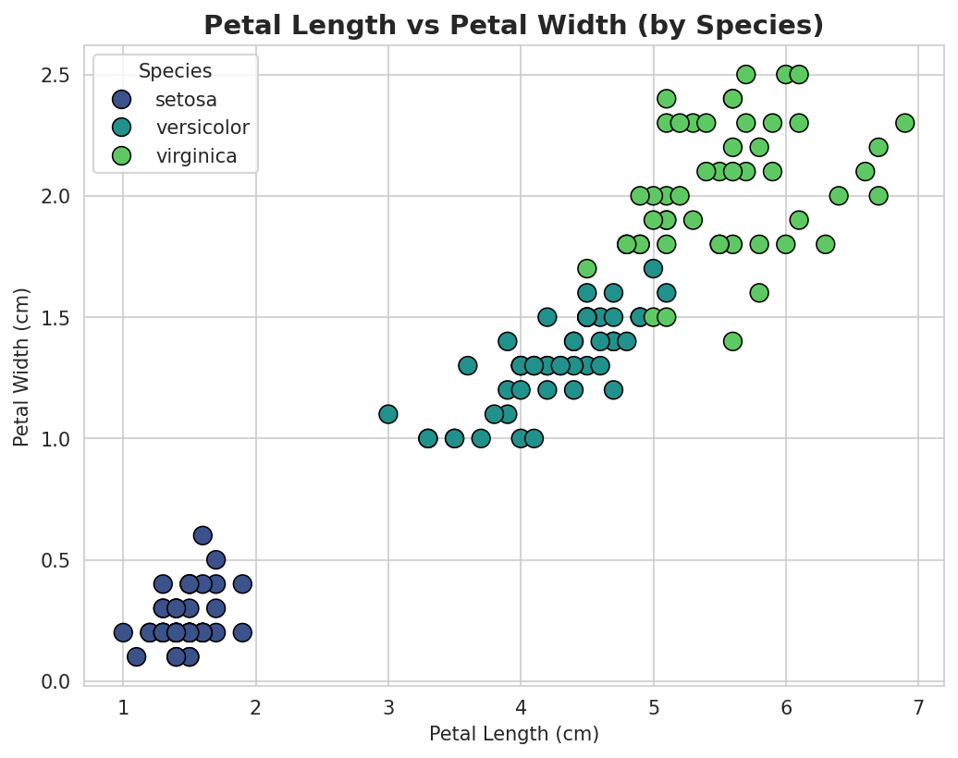
Figure 3: Scatter plot of petal length vs petal width, colored by species.
This is the most informative pair of features in the dataset, the three species form visibly distinct clusters, especially setosa which is fully separated from the other two.

5.4 Sepal Length vs Sepal Width
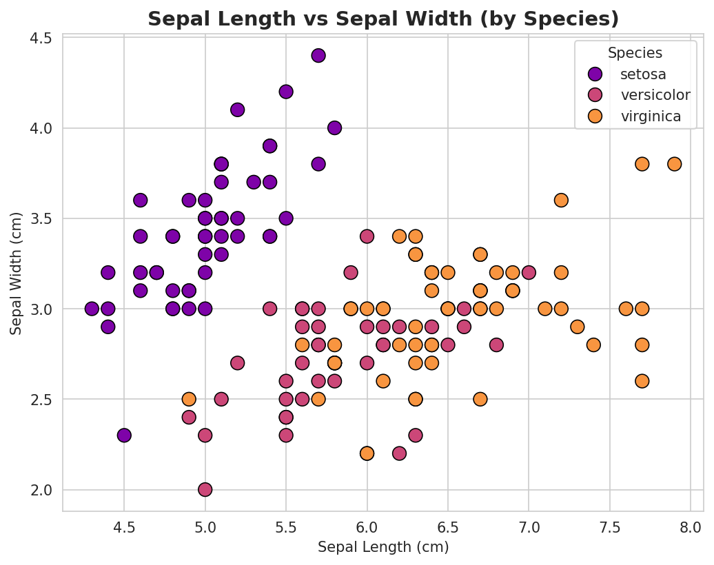
Figure 4: Scatter plot of sepal length vs sepal width, colored by species.
Sepal measurements show more overlap between versicolor and virginica compared to petal measurements, making them less useful on their own for distinguishing these two species.

5.5 Pairplot of All Features
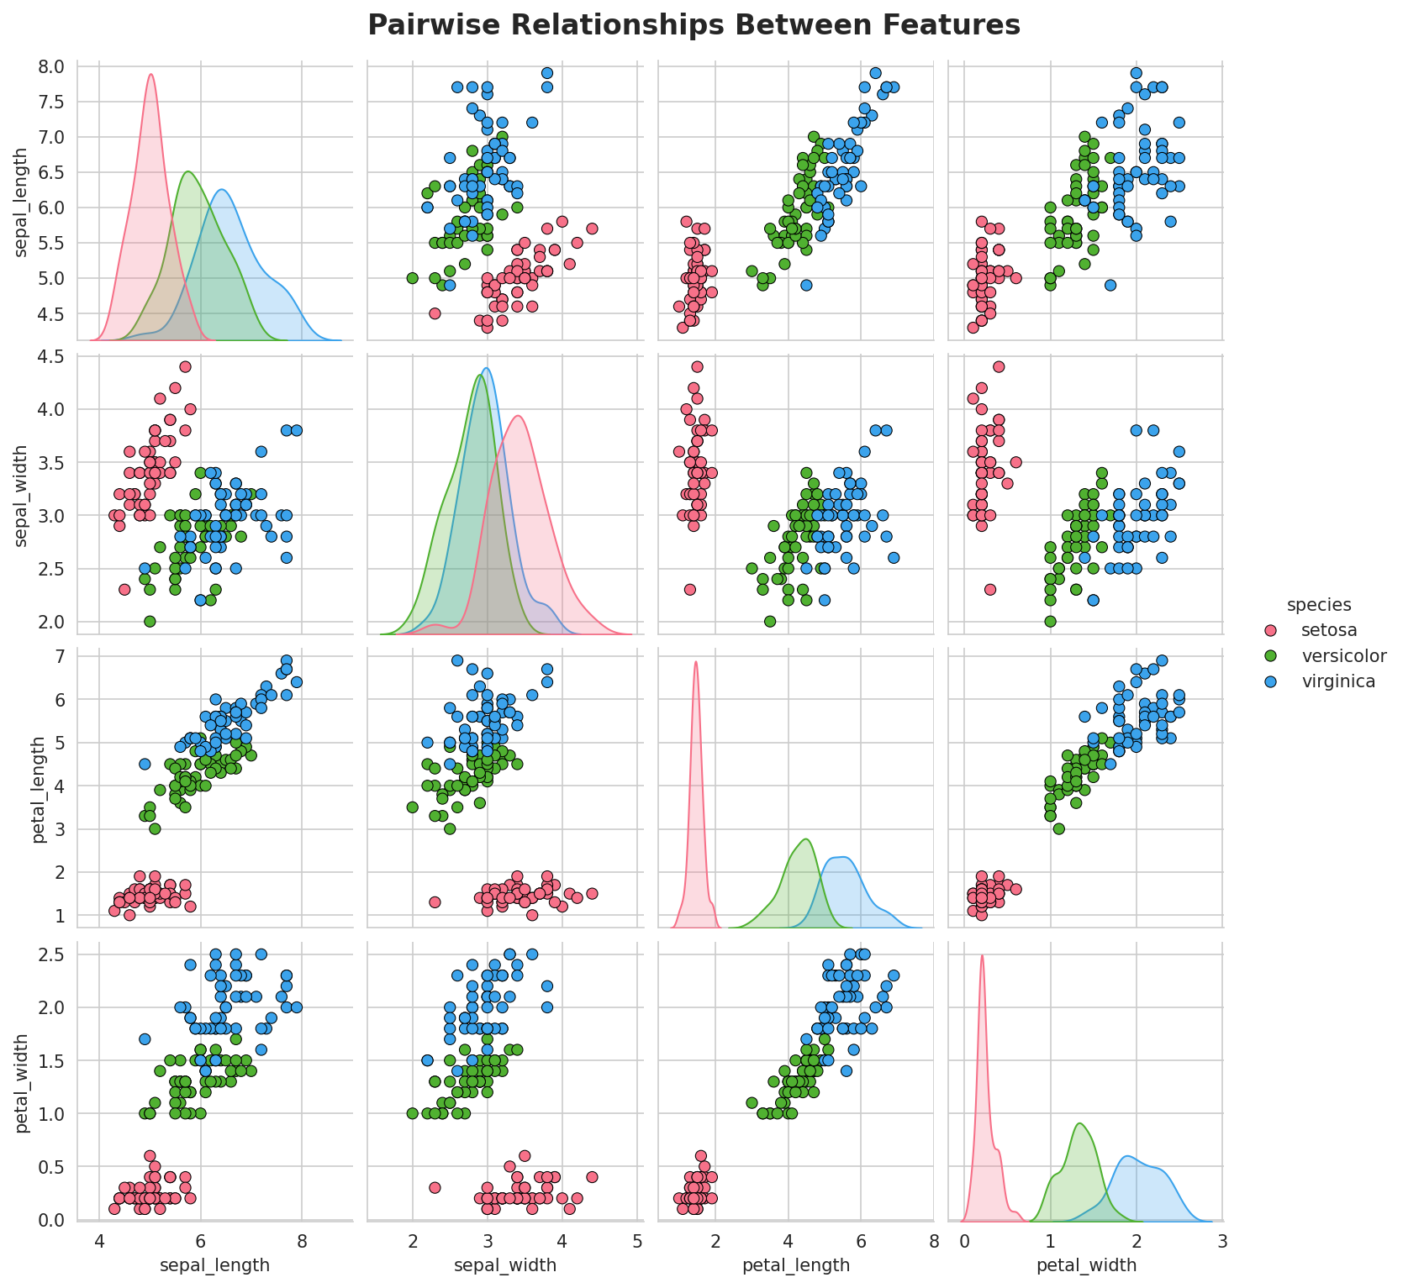
Figure 5: Pairwise relationships between all four features, colored by species.

5.6 Correlation Heatmap
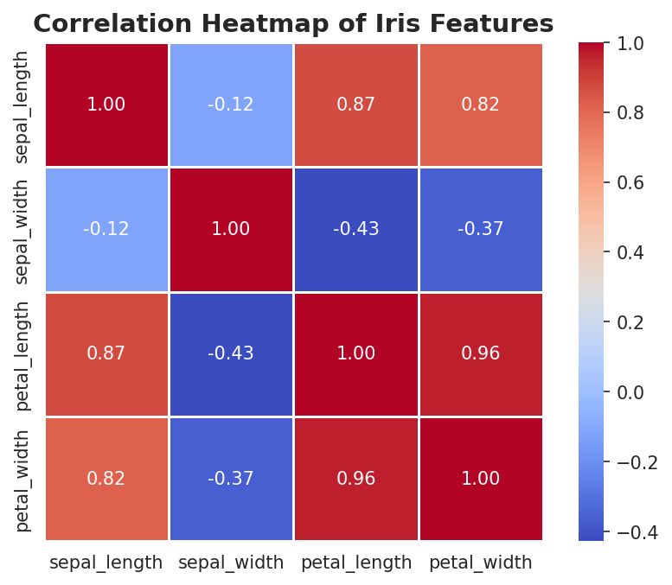
Figure 6: Correlation heatmap of the four numeric features.
Petal length and petal width are very strongly correlated (≈0.96). Sepal width shows a weak, slightly negative correlation with the other features.

5.7 Species Distribution
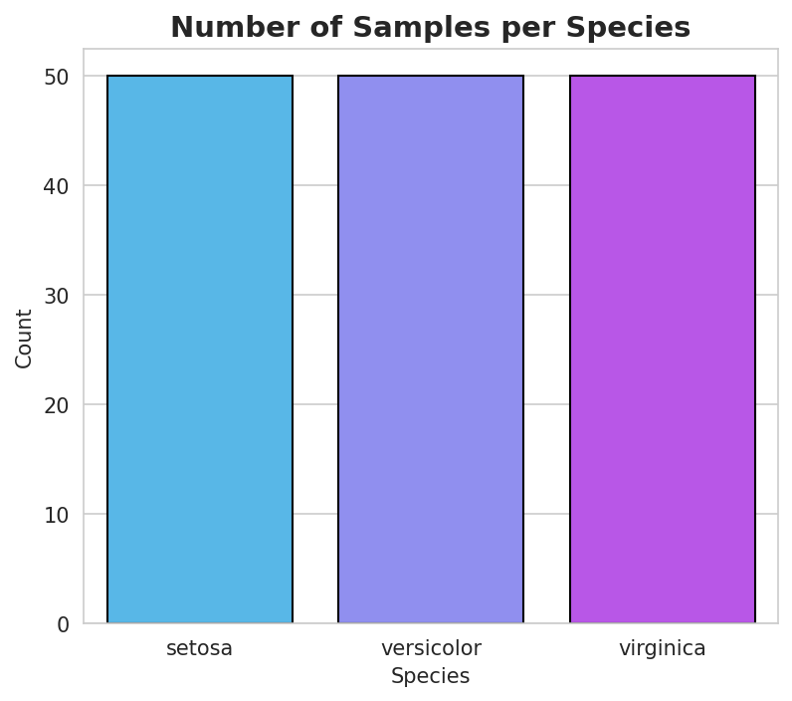
Figure 7: Number of samples per species.

6. Key Insights Summary
- The dataset is clean, balanced, and requires no missing-value handling.
- Petal length and petal width are the strongest, most correlated features and best separate the species.
- Setosa is easily distinguishable from the other two species using petal measurements alone.
- Versicolor and virginica overlap more and would need multiple features or a classification model to separate reliably.
- Sepal width is the least informative feature for distinguishing species.

7. Conclusion
This EDA gave us a clear understanding of the Iris dataset's structure and the relationships between its features. The insights gathered here particularly the strong discriminative power of petal measurements would directly inform feature selection for a future classification model (e.g., Logistic Regression, KNN, or Decision Tree).

8. Tools Used
- Python 3, Jupyter Notebook
- pandas, numpy for data handling
- matplotlib, seaborn for data visualization

